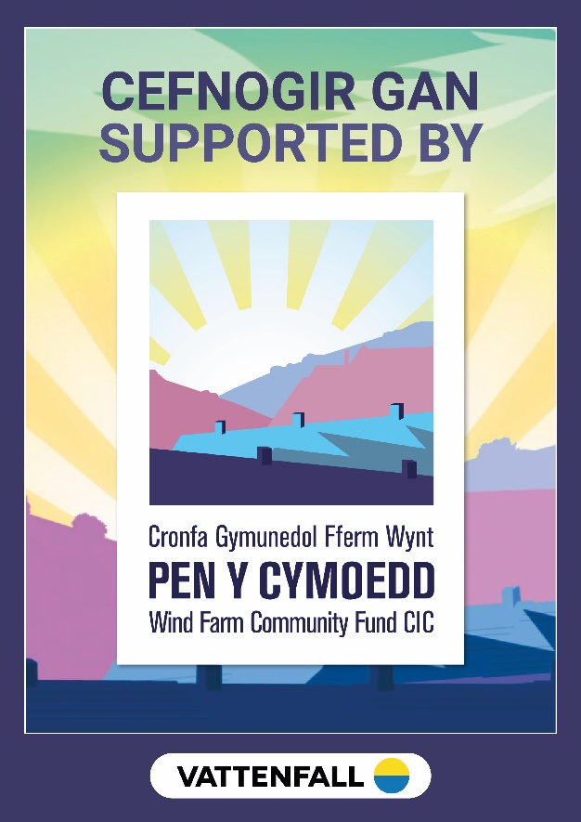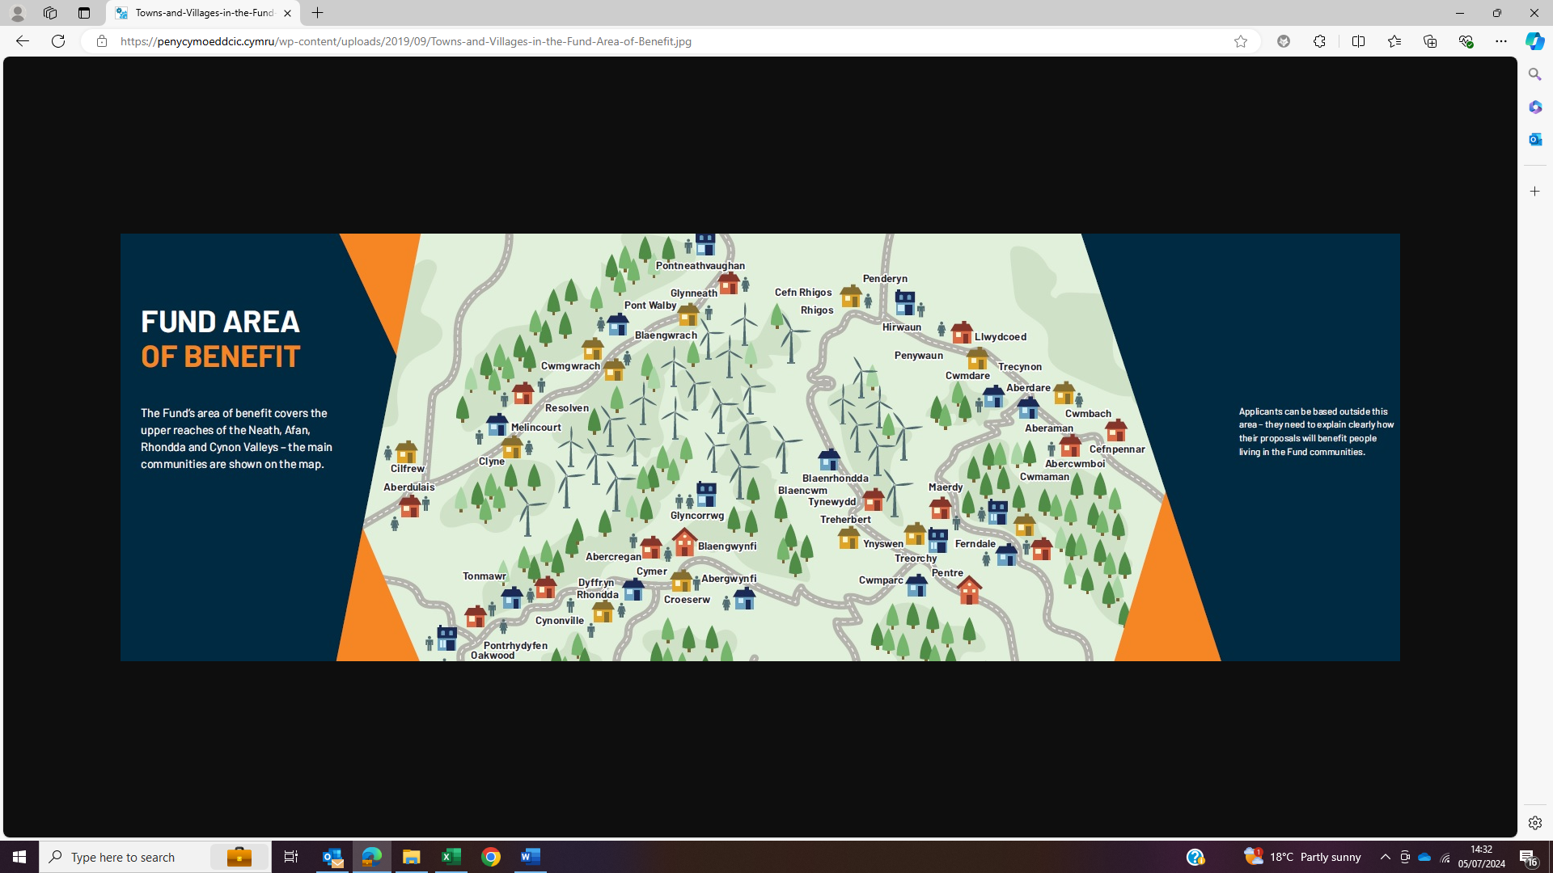

NEATH VALLEY AWARDS
120 Micro Awards Made
35 Vision Awards Made
21 Covid Support and other awards Made
Total investment in valley £3,231,034.44

Type of Award | Organisation | Location | Project Name | Year | Loan, Grant or Loan/Grant Mix | Grant | Loan
Vision Fund | Class Act Tutoring | Across Neath and Cynon | Class Act Tutoring new business start up | 2024 | Loan / Grant Mix | £6,500.00 | £11,419.11
Vision Fund | Resolven RFC | Neath | Solar, Battery and EVCPs | 2024 | Grant | £23,591.00 | £0.00
Vision Fund | NPT CVS | Across Neath and Afan | Supporting our communities 2024-2027 | 2024 | Grant | £150,000.00 | £0.00
Micro Fund Business | Moonshine Events UK | Neath | Moonshine Events | 2024 | Grant | £3,600.00 | £0.00
Micro Fund Business | Village Tiling | Neath | Village Tiling | 2024 | Grant | £2,500.00 | £0.00
Micro Fund Business | The Tea Rooms | Neath | The Travelling Tea Room | 2024 | Grant | £2,694.88 | £0.00
Micro Fund Business | Sparkle Sisters | Neath | Sparkle Sisters Cleaning | 2024 | Grant | £5,238.00 | £0.00
Micro Fund Community | Ynysygerwn Community Sport and Social Club | Neath | Project Clubhouse | 2024 | Grant | £6,500.00 | £0.00
Micro Fund Community | Thrive Women's Aid | Neath | In House Specialist Domestic Abuse Counsellor | 2024 | Grant | £6,500.00 | £0.00
Micro Fund Community | Friends of Clyne and Melincourt | Neath | Friends of Clyne and Melincourt | 2024 | Grant | £1,100.00 | £0.00
Micro Fund Community | Cilfrew Community Health and Wellbeing Group | Neath | Cilfrew Community Health and Wellbeing Group | 2024 | Grant | £2,187.00 | £0.00
Micro Fund Community | The Ganu Hall | Neath | Breathing life into our beloved Ganu | 2024 | Grant | £6,380.00 | £0.00
Micro Fund Community | Green Footprints Neath | Neath | Green Orchard. Green story time Green fingers | 2024 | Grant | £2,750.00 | £0.00
Micro Fund Community | Glynneath ALN | Neath | Glynneath ALN | 2024 | Grant | £460.00 | £0.00
Micro Fund Community | Cwmgwrach RFC | Neath | Scrummage Machine Uplift | 2024 | Grant | £5,950.00 | £0.00
Micro Fund Business | Kraken Clean | Neath | Carpet Cleaning | 2024 | Grant | £6,494.44 | £0.00
Micro Fund Business | Ceri Pritchard Counselling Services | Neath | Start Up | 2024 | Grant | £2,932.98 | £0.00
Micro Fund Business | Solo Presents Ltd | Neath | The growth of Solo Presents | 2024 | Grant | £6,500.00 | £0.00
Micro Fund Business | Phill Godfrey Painting and Decorating Services | Neath | Spray Painting | 2024 | Grant | £5,200.00 | £0.00
Micro Fund Business | Bramwood Timber Products | Neath | Manito telehandler | 2024 | Grant | £6,500.00 | £0.00
Micro Fund Community | Pontneddfechan Old Age Pensioners Association | Neath | OAPs Get Out and About | 2024 | Grant | £1,100.00 | £0.00
Micro Fund Community | VonCon | Neath | Fostering friendships through Tabletop Gaming | 2024 | Grant | £1,100.00 | £0.00
Micro Fund Community | Friends of Craig Gwladus | Neath | Replacement of six Picnic benches. | 2024 | Grant | £2,916.00 | £0.00
Vision Fund | Vale Of Neath Community Leisure Ltd (Trainstation Gym, Glynneath) | Neath | Fire and Ice | 2023 | Loan / Grant Mix | £6,500.00 | £18,867.00
Vision Fund | EESW - Engineering Education Scheme Wales Ltd | Across all valleys | Wind Turbine Construction Workshop | 2023 | Grant | £24,752.25 | £0.00
Vision Fund | Initiative for Nature Conservation Cymru (INCC) | Across all valleys | Saving our Water Voles | 2023 | Grant | £124,052.30 | £0.00
Vision Fund | NRW (Neurological Rehabilitation Wales) | Across all valleys | Strengthening Life | 2023 | Grant | £93,336.50 | £0.00
Vision Fund | NPT CVS | Across Neath and Afan | Supporting Communities Phase 2 | 2023 | Grant | £64,604.00 | £0.00
Vision Fund | Cranfield Trust | Across all valleys | Stronger Charities, Stronger Communities | 2023 | Grant | £64,050.00 | £0.00
Vision Fund | The Tea Rooms | Neath | Help, we need somebody | 2023 | Grant | £22,609.58 | £0.00
Vision Fund | Resolven Building Blocks | Neath | The Growth and Mindset Project Phase 2 | 2023 | Grant | £144,964.52 | £0.00
Micro Fund Business | Ian J. Currie | Neath | Essays on the History of Glynneath | 2023 | Grant | £600.00 | £0.00
Micro Fund Business | Tumbleweed | Neath | Business Expansion | 2023 | Grant | £1,725.97 | £0.00
Micro Fund Business | Glynneath Bakery | Neath | Glynneath Bakery - Phase 1, Delivering a service for the needs of the community... | 2023 | Grant | £5,630.02 | £0.00
Micro Fund Business | Ceridwen Mai Designs | Neath | Ceridwen Mai Designs | 2023 | Grant | £3,193.00 | £0.00
Micro Fund Community | Call of the Wild Development Trust CIC | Neath | Resilient Pupil Programme | 2023 | Grant | £3,690.00 | £0.00
Micro Fund Community | Celtic Archers | Neath | The 3 'R's | 2023 | Grant | £694.00 | £0.00
Micro Fund Community | Neath Valley Music Club | Neath | Neath Valley Music Club | 2023 | Grant | £345.00 | £0.00
Micro Fund Community | Friends of the Town Hall Glynneath | Neath | Glynneath Town Hall Mural Project | 2023 | Grant | £3,275.00 | £0.00
Micro Fund Community | Green Footprints Neath | Neath | Community Communication and Appreciation | 2023 | Grant | £2,871.00 | £0.00
Micro Fund Community | Spring Valley Paddlers | Neath | Spring Valley Paddlers Community Development | 2023 | Grant | £3,600.00 | £0.00
Micro Fund Community | 13th Cwmgwrach Scouts Group | Neath | Scouts Go Green! | 2023 | Grant | £3,965.00 | £0.00
Micro Fund Community | Resolven Rugby Football and Cricket Club | Neath | Double trouble | 2023 | Grant | £4,537.51 | £0.00
Micro Fund Business | X-Clusive Dance | Neath | Dancing for Health and Wellbeing | 2023 | Grant | £2,544.97 | £0.00
Micro Fund Business | CracKDIt | Neath | CracKDIt | 2023 | Grant | £2,300.00 | £0.00
Micro Fund Business | The Vault Embroidery | Neath | The Vault Embroidery @ Resolven | 2023 | Grant | £2,400.00 | £0.00
Micro Fund Business | South Wales Blinds Ltd | Neath | Build for the future | 2023 | Grant | £5,000.00 | £0.00
Micro Fund Community | Empower Inspire CIC | Neath | Singing for the Brain, Cwmgwrach | 2023 | Grant | £4,952.00 | £0.00
Micro Fund Community | Cwmgwrach RFC | Neath | Moving Forward | 2023 | Grant | £2,000.00 | £0.00
Micro Fund Community | Resolven Bowls Club | Neath | The 91 - an annual tournament celebrating our club's history, leading up to our centenary in 2032 | 2023 | Grant | £2,698.00 | £0.00
Micro Fund Community | Resolven Village Seniors | Neath | A Couple of Day Trips | 2023 | Grant | £620.00 | £0.00
Micro Fund Community | Llangatwg Health and Wellbeing | Neath | Healthy Lives | 2023 | Grant | £1,225.00 | £0.00
Vision Fund | Resolven Miners Welfare Scheme | Neath | Feasibility Study for the Restoration of the Resolven Miners Welfare | 2022 | Grant | £36,177.00 | £0.00
Vision Fund | Glynneath Training Centre | Neath | Under the Sky Growing and Learning – Phase 2 | 2022 | Grant | £62,416.07 | £0.00
Vision Fund | Severn Wye | Across all valleys | Building Energy Audits | 2022 | Grant | £30,000.00 | £0.00
Vision Fund | Resolven AFC | Neath | Renewing the Club | 2022 | Loan/Grant Mix | £90,000.00 | £21,443.42
Vision Fund | Resolven AFC | Neath | Solar Panel Installation | 2022 | Loan | £0.00 | £32,400.00
Vision Fund | Cymru Hearts | Across all valleys | Pen y Cymoedd Defibrillators | 2022 | Grant | £117,316.00 | £0.00
Vision Fund | Our Space | Across all valleys | Our Space – Ein Lle Ni | 2022 | Grant | £81,866.80 | £0.00
Vision Fund | Resolven RFC | Neath | Improving facilities and sustainability | 2022 | Grant | £19,893.79 | £0.00
Micro Fund Business | Stephen Harris Physical Therapy and Rehabilitation | Neath | Stephen Harris Physical Therapy and Rehabilitation | 2022 | Grant | £5,000.00 | £0.00
Micro Fund Community | Ty Banc Canal Group | Neath | Turn 2 Ty Banc | 2022 | Grant | £1,100.00 | £0.00
Micro Fund Community | Resolven AFC (Ladies) | Neath | Resolven Ladies AFC | 2022 | Grant | £1,110.00 | £0.00
Micro Fund Community | Resolven Community Council | Neath | Toilet hell to Toilet heaven | 2022 | Grant | £5,000.00 | £0.00
Micro Fund Business | Glynneath Town FC Ltd | Neath | Kitchen Renovation | 2022 | Grant | £4,931.35 | £0.00
Micro Fund Business | Darren and Emma's Breakfast Bar | Neath | Improving service in the kitchen | 2022 | Grant | £3,840.00 | £0.00
Micro Fund Community | Cilfrew Community Connections | Neath | Connecting our Community | 2022 | Grant | £1,100.00 | £0.00
Micro Fund Community | Siop y Ddraig Goch | Neath | Siop y Ddraig Goch | 2022 | Grant | £5,000.00 | £0.00
Micro Fund Community | Resolven Community Events Group | Neath | Resolven Carnival 2022 | 2022 | Grant | £1,100.00 | £0.00
Micro Fund Community | Glynneath Town FC Ladies | Neath | Glynneath Town Ladies AFC | 2022 | Grant | £1,181.00 | £0.00
Micro Fund Community | Pontneddfechan Village Hall | Neath | Village Hall Door Renewal | 2022 | Grant | £5,000.00 | £0.00
Micro Fund Community | Blaengwrach Community Council | Neath | Cwmgwrach Connectivity | 2022 | Grant | £1,175.00 | £0.00
Micro Fund Community | Pontneddfechan OAP | Neath | Post Pandemic for Pontneddfechan OAPs | 2022 | Grant | £428.75 | £0.00
Micro Fund Community | Resolven Bowls Club | Neath | The Ninety - a 90th Birthday Bowls Tournament | 2022 | Grant | £3,232.00 | £0.00
Vision Fund | Resolven Building Blocks | Neath | The Growth and Mindset Project | 2021 | Grant | £63,489.98 | £0.00
Vision Fund | Glynneath Golf Club | Neath | Driving Golf at Glynneath | 2021 | Grant | £110,000.00 | £0.00
Micro Fund Business | Vision Electronic Security Solutions | Neath | Vision Start-Up | 2021 | Grant | £4,400.00 | £0.00
Micro Fund Business | That Doughnut Place | Neath | Comfort and Capacity Upgrade | 2021 | Grant | £2,651.88 | £0.00
Micro Fund Business | South Wales Blinds Ltd | Neath | Development Phase 2 | 2021 | Grant | £3,236.67 | £0.00
Micro Fund Business | Vensports Ltd - Trainstation | Neath | The Gym Guys | 2021 | Grant | £2,900.00 | £0.00
Micro Fund Business | Dan Wintle Gas Engineer | Neath | Dan Wintle Gas Engineer | 2021 | Grant | £1,613.80 | £0.00
Micro Fund Business | Davies Plant and Agri | Neath | Additional Equipment | 2021 | Grant | £2,000.00 | £0.00
Micro Fund Business | The Tea Rooms | Neath | Tea Room Improvements | 2021 | Grant | £3,000.00 | £0.00
Micro Fund Business | Fork Fix Ltd | Neath | Equipment | 2021 | Grant | £3,747.00 | £0.00
Micro Fund Business | Lunabell Camping | Neath | Lunabell Events - trading as Lunabell (Glamping and Picnic Events) | 2021 | Grant | £4,822.98 | £0.00
Micro Fund Business | Sew Happy | Neath | Sew Happy | 2021 | Grant | £2,636.80 | £0.00
Micro Fund Community | Cwmgwrach Amateur Boxing Club | Neath | Community Group Enhancements | 2021 | Grant | £3,092.60 | £0.00
Micro Fund Community | Green Infrastructure Group | Neath | Stronger Together | 2021 | Grant | £2,500.00 | £0.00
SMALL ENTREPRENEURSHIP GRANT | Caroline Lewis | Neath | Caroline Lewis | 2021 | Grant | £1,200.00 | £0.00
Vision Fund | Canal View Café | Neath | Emergency Flooding Loan | 2020 | Loan | £0.00 | £20,000.00
Vision Fund | Glynneath RFC | Neath | Glynneath RFC Development | 2020 | Loan/Grant Mix | £54,593.50 | £20,000.00
Vision Fund | Community Impact Initiative | Across all Valleys | Building Resilience in the Community | 2020 | Grant | £276,265.00 | £0.00
Micro Fund Business | South Wales Blinds Ltd | Neath | The next Level | 2020 | Grant | £4,400.00 | £0.00
Micro Fund Business | Darren Evans Kitchen Fitter | Neath | Darren Evans Kitchen Fitter | 2020 | Grant | £1,919.00 | £0.00
Micro Fund Business | The Tea Rooms | Neath | Room Hire for Self-Employed | 2020 | Grant | £2,100.00 | £0.00
Micro Fund Business | Steve G Garden Services | Neath | Steve G Garden Services | 2020 | Grant | £1,935.97 | £0.00
Micro Fund Community | Ty Banc Canal Group | Neath | Keep Canal Tidy/Explore Neath Canal | 2020 | Grant | £4,750.09 | £0.00
Micro Fund Community | Resolven AFC | Neath | Bar Renovations Phase 2 | 2020 | Grant | £4,811.55 | £0.00
Micro Fund Community | Proactive Pontneddfechan | Neath | Pobl a Phlanhigion Pontneddfechan | 2020 | Grant | £3,306.76 | £0.00
Micro Fund Business | WR Lloyd Timber | Neath | Reduce Waste | 2020 | Grant | £2,500.00 | £0.00
Micro Fund Business | SEAS Ltd | Neath | Growth of SEAS | 2020 | Grant | £2,853.00 | £0.00
Micro Fund Business | Fresh and Fine Foods | Neath | Fresh and Fine Foods | 2020 | Grant | £4,071.04 | £0.00
Micro Fund Business | TJH Roofing and Building Services | Neath | TJH Roofing and Building Services | 2020 | Grant | £3,000.00 | £0.00
Micro Fund Business | South Wales Adventure Company | Neath | Storage Improvements | 2020 | Grant | £2,370.00 | £0.00
Micro Fund Business | HeadWork Barber Shop | Neath | Headwork Barber Shop | 2020 | Grant | £2,450.00 | £0.00
Micro Fund Business | QS Sak Ltd - Glynneath WGM | Neath | Constructing the Team | 2020 | Grant | £1,749.00 | £0.00
Micro Fund Community | Addiscott Arts Academy | Neath | 2020 Arts Academy Expansion | 2020 | Grant | £3,454.00 | £0.00
Micro Fund Community | Vale of Neath Parish | Neath | Noah's Arc | 2020 | Grant | £5,000.00 | £0.00
Micro Fund Community | Inspirational Futures Wellbeing Support | Neath | Well-beeing Workshops | 2020 | Grant | £3,480.00 | £0.00
COVID SUPPORT | Bramwood Timber Products | Neath | Bramwood Timber Products | 2020 | Loan/Grant Mix | £1,000.00 | £11,663.40
COVID SUPPORT | Vensports Ltd - Trainstation | Neath | Vensports Ltd - Trainstation | 2020 | Grant | £3,918.00
COVID SUPPORT | Trust Scaffolding | Neath | Trust Scaffolding | 2020 | Loan/Grant Mix | £8,113.30 | £8,113.50
COVID SUPPORT | Neurological Rehabilitation Wales | Neath | Neurological Rehabilitation Wales | 2020 | Loan | £0.00 | £7,500.00
COVID SUPPORT | Doherty’s | Neath | Doherty’s | 2020 | Grant | £5,288.00
COVID SUPPORT | Darren Evans Kitchen Fitter | Neath | Darren Evans Kitchen Fitter | 2020 | Grant | £1,384.00
COVID SUPPORT | Cwmgwrach Amateur Boxing Club | Neath | Cwmgwrach Amateur Boxing Club | 2020 | Grant | £1,300.00
COVID SUPPORT | KJB Cleaning Solutions | Neath | KJB Cleaning Solutions | 2020 | Grant | £2,458.00
COVID SUPPORT | Cwmgwrach RFC | Neath | Cwmgwrach RFC | 2020 | Grant | £2,017.84
COVID SUPPORT | Millennium Rail | Neath | Millennium Rail | 2020 | Loan | £0.00 | £3,500.00
COVID SUPPORT | Homeland Wales | Neath | Homeland Wales | 2020 | Grant | £1,270.00
COVID SUPPORT | Resolven Miner’s Welfare | Neath | Resolven Miner’s Welfare | 2020 | Grant | £4,074.00
COVID SUPPORT | Cylch Meithrin Cwmnedd | Neath | Cylch Meithrin Cwmnedd | 2020 | Grant | £3,500.00
COVID SUPPORT | Vale of Neath Patient Participation Group | Neath | Vale of Neath Patient Participation Group | 2020 | Grant | £4,000.00
COVID SUPPORT | SNAP Cymru | Neath and Afan | SNAP Cymru | 2020 | Grant | £12,670.00
COVID SUPPORT | The Mine | Neath | The Mine | 2020 | Grant | £5,000.00
COVID SUPPORT | Shelter Cymru | Neath and Afan | Shelter Cymru | 2020 | Grant | £13,886.00
COVID SUPPORT | Age Connects Neath Port Talbot | Neath | Age Connects Neath Port Talbot | 2020 | Grant | £2,080.00
COVID SUPPORT | Ysgol Cwm Brombil | Neath | Ysgol Cwm Brombil | 2020 | Grant | £5,700.00
COVID SUPPORT | Glynneath Training Centre | Neath | Glynneath Training Centre | 2020 | Grant | £12,220.24
Vision Fund | Sgwd Gwladys | Neath | Sgwd Gwladys Outside Eatery | 2019 | Loan/Grant Mix | £6,509.39 | £10,490.61
Vision Fund | The Mine | Neath | The Mine Bistro | 2019 | Loan/Grant Mix | £6,500.00 | £17,500.00
Vision Fund | Bramwood Timbers | Neath | Bramwood Timber Showroom | 2019 | Grant | £22,696.89 | £0.00
Vision Fund | Ystradfellte Community Council | Neath | Dyfodol y Dyfroedd / Waterfall Country Futures | 2019 | Grant | £54,000.00 | £0.00
Vision Fund | Canal View Café | Neath | Canal View Café | 2019 | Grant | £15,000.00 | £0.00
Vision Fund | Ty Coffi Cilfrew | Neath | Ty Coffi Cilfrew | 2019 | Grant | £25,000.00 | £0.00
Micro Fund Business | Phill Godfrey Painting and Decorating Services | Neath | Phill Godfrey Painting and Decorating Services | 2019 | Grant | £3,000.00 | £0.00
Micro Fund Business | Infinity Running | Neath | Run for your life! | 2019 | Grant | £5,000.00 | £0.00
Micro Fund Business | Quick Cuts | Neath | Quick Cuts Barber | 2019 | Grant | £2,000.00 | £0.00
Micro Fund Community | Glynneath Community Events Panel | Neath | Together, whatever the weather! | 2019 | Grant | £4,613.00 | £0.00
Micro Fund Community | Resolven and District Community Library | Neath | New Library Frontage | 2019 | Grant | £2,700.00 | £0.00
Micro Fund Community | Glynneath Town AFC | Neath | Glyn Footy | 2019 | Grant | £2,000.00 | £0.00
Micro Fund Business | Chic | Neath | Always time for tea and nails | 2019 | Grant | £5,000.00 | £0.00
Micro Fund Community | Friends of Ynysfach Primary School | Neath | Outdoor Sports Facility | 2019 | Grant | £3,941.23 | £0.00
Micro Fund Community | Resolven Rugby Football and Cricket Club | Neath | Essential Storage | 2019 | Grant | £2,500.00 | £0.00
Micro Fund Community | Nexus Valley Swimming Club | Neath | Development and Training Aids | 2019 | Grant | £1,938.00 | £0.00
Vision Fund | NPT CVS | Across all Valleys | Supporting the Delivery of the PyC Fund | 2018 | Grant | £434,964.65 | £0.00
Vision Fund | The Tired Mama Collection | Neath | Growth Plan | 2018 | Grant | £23,065.00 | £0.00
Vision Fund | Blaengwrach Community Council | Neath | Redevelopment of Cwmgwrach Welfare Park | 2018 | Grant | £99,000.00 | £0.00
Micro Fund Community | Cylch Meithrin Cwmnedd | Neath | New Playroom | 2018 | Grant | £2,061.12 | £0.00
Micro Fund Community | Music in Hospitals and Care | Neath | Music and Memories | 2018 | Grant | £4,504.00 | £0.00
Micro Fund Community | Cor Meibion Glyn-nedd | Neath | Look # | 2018 | Grant | £4,400.00 | £0.00
Micro Fund Community | Resolven Village Seniors | Neath | Active Plus Project | 2018 | Grant | £800.00 | £0.00
Micro Fund Community | Glynneath Town FC | Neath | Glynneath AFC | 2018 | Grant | £2,500.00 | £0.00
Micro Fund Business | EcoServ West | Neath | Expansion - Phase One! | 2018 | Grant | £3,800.00 | £0.00
Micro Fund Business | Naturally Neath | Neath | Naturally Neath | 2018 | Grant | £4,313.04 | £0.00
Micro Fund Business | Vensports Ltd - Trainstation | Neath | Moving Fitness Forward | 2018 | Grant | £4,700.00 | £0.00
Micro Fund Business | Sgwd Gwladys | Neath | Sgwd Gwladys | 2018 | Grant | £5,000.00 | £0.00
Micro Fund Community | Pontneathvaughan Village Hall | Neath | Village Hall Update and Improvements | 2018 | Grant | £2,546.00 | £0.00
Micro Fund Community | Ynysygerwn Community Sport and Social Club | Neath | Keep Kids Playing Outside, Keep Adults Active | 2018 | Grant | £2,652.00 | £0.00
Micro Fund Community | Cwmgwrach Amateur Boxing Club | Neath | CABC | 2018 | Grant | £3,226.32 | £0.00
Micro Fund Community | Three Valleys Nordic Walking | Neath | Nordic Walking Back to Happiness | 2018 | Grant | £1,480.00 | £0.00
Micro Fund Community | Cwmgwrach Moving Forward | Neath | Picnic in the Parc | 2018 | Grant | £800.00 | £0.00
Vision Fund | Awel Aman Tawe | Neath | Egni Solar Co-Op | 2017 | Grant | £30,000.00 | £0.00
Vision Fund | View Ltd - Glynneath TC | Neath | Under the Sky Growing and Learning | 2017 | Grant | £194,258.00 | £0.00
Micro Fund Community | Glynneath Community First Responders | Neath | AEDs and Training Our Community | 2017 | Grant | £4,050.00 | £0.00
Micro Fund Community | Cwmgwrach RFC | Neath | Community Shower Refurbishment | 2017 | Grant | £4,606.00 | £0.00
Micro Fund Community | Welsh Athletic Run Wales | Across all Valleys | Get Pen y Cymoedd Running | 2017 | Grant | £2,520.00 | £0.00
Micro Fund Community | Friends of Craig Gwladus | Neath | Caring for Craig Gwladus | 2017 | Grant | £3,750.00 | £0.00
Micro Fund Community | Pontneddfechan OAP | Neath | Up, up and Away! | 2017 | Grant | £1,000.00 | £0.00
Micro Fund Community | Resolven Young Performers | Neath | RYP Growth and Improvement | 2017 | Grant | £1,855.00 | £0.00
Micro Fund Community | Cwmgwrach OAP Association | Neath | Ancient Visiting Ancient | 2017 | Grant | £1,000.00 | £0.00
Micro Fund Community | Glynneath Allotments Society | Neath | Growing Healthy Hearts, Mind and Community | 2017 | Grant | £4,982.00 | £0.00
Micro Fund Community | Resolven Community Council | Neath | Swings and Slides | 2017 | Grant | £5,000.00 | £0.00
Micro Fund Community | Clyne Community Group | Neath | Community Engagement | 2017 | Grant | £2,678.08 | £0.00
Micro Fund Community | Glynneath Town Council | Neath | Community Consultation | 2017 | Grant | £5,000.00 | £0.00
Micro Fund Community | The Fane Art Club | Neath | Tutor and Models | 2017 | Grant | £750.00 | £0.00

