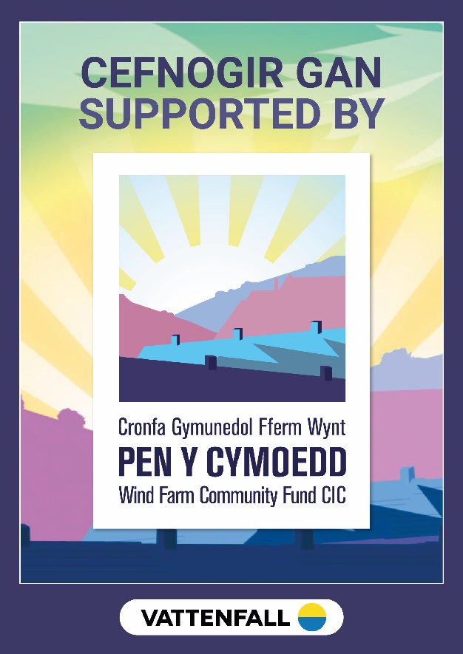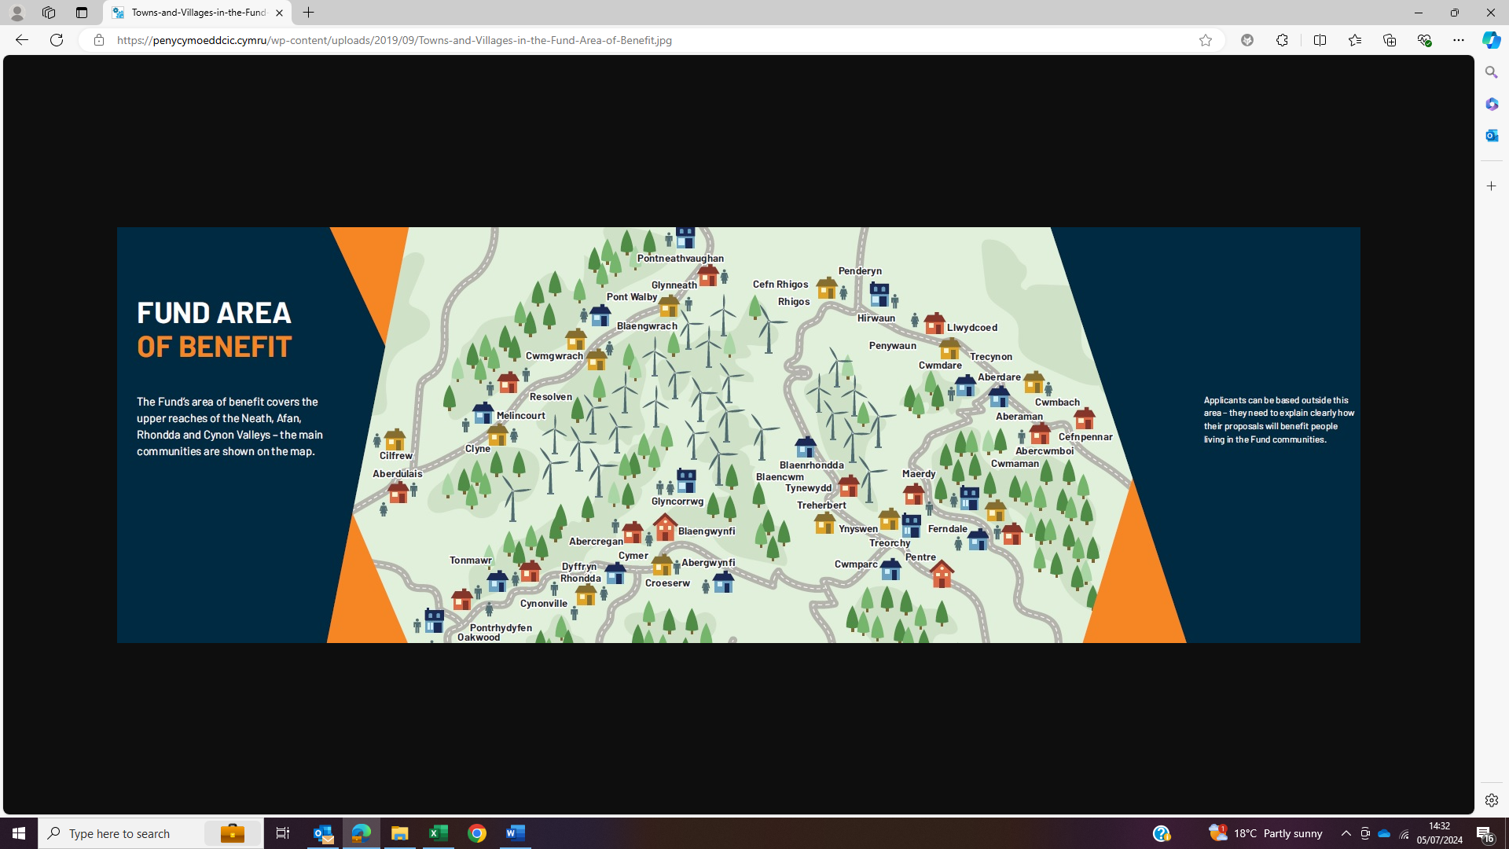

AFAN VALLEY AWARDS
100 Micro Awards Made
34 Vision Awards Made
21 Covid Support and other awards Made
Total investment in valley £2,811,356.58
Type of Award | Organisation | Location | Project Name | Year | Loan, Grant or Loan/Grant Mix | Grant | Loan
Vision Fund | Library+ Cymer Library | Afan | Consolidating and Planning for our future | 2024 | Grant | £26,000.00 | £0.00
Vision Fund | NPT CVS | Across Neath and Afan | Supporting our communities 2024-2027 | 2024 | Grant | £150,000.00 | £0.00
Vision Fund | Pontrhydyfen Weight Training Association | Afan | Project Upgrade | 2024 | Grant | £6,500.00 | £0.00
Vision Fund | Cymmer Bowls Club | Afan | Smarten Up & Celebrate Our Centenary | 2024 | Grant | £20,750.00 | £0.00
Vision Fund | Goalgetters Soccer School CIC | Afan | Afan Valley Football | 2024 | Grant | £100,000.00 | £0.00
Micro Fund Business | Bryn Bettws Lodge | Afan | Warmer Winter | 2024 | Grant | £5,093.00 | £0.00
Micro Fund Community | Burton Bont Festival | Afan | It's more than a tent! A Marquee for Community Celebrations and Anniversaries for 2025 and beyond. | 2024 | Grant | £5,553.40 | £0.00
Micro Fund Community | Valley Vipers | Afan | The Vipers are Coming! | 2024 | Grant | £2,027.82 | £0.00
Micro Fund Community | Cymer Afan Primary School PTA | Afan | Cymer Afan Play Park Phase 2 | 2024 | Grant | £6,500.00 | £0.00
Micro Fund Community | Croeserw Bowls Club | Afan | Upskilling Members Green Management | 2024 | Grant | £1,650.00 | £0.00
Micro Fund Community | Tonmawr Dragonettes | Afan | Tonmawr Dragonettes | 2024 | Grant | £3,060.00 | £0.00
Micro Fund Community | Pelenna Community Council | Afan | Picnic in the Parc | 2024 | Grant | £3,309.34 | £0.00
Micro Fund Community | Afan Valley Swimming Club | Afan | Swimming Club Growth | 2024 | Grant | £4,452.00 | £0.00
Micro Fund Community | Pontrhydyfen RFC | Afan | New Sport and Community Hub | 2024 | Grant | £6,500.00 | £0.00
Micro Fund Community | Pontrhydyfen Community Centre | Afan | Pontrhydyfen Community Centre Refurbishment and Hall Renaming | 2024 | Grant | £6,275.00 | £0.00
Micro Fund Community | St Teilo | Afan | St Teilo Community Project | 2024 | Grant | £4,841.82 | £0.00
Vision Fund | EESW - Engineering Education Scheme Wales Ltd | Across all valleys | Wind Turbine Construction Workshop | 2023 | Grant | £24,752.25 | £0.00
Vision Fund | Initiative for Nature Conservation Cymru (INCC) | Across all valleys | Saving our Water Voles | 2023 | Grant | £124,052.30 | £0.00
Vision Fund | NRW (Neurological Rehabilitation Wales) | Across all valleys | Strengthening Life | 2023 | Grant | £93,336.50 | £0.00
Vision Fund | Pontrhydyfen Bowls | Afan | Bowls For Everyone – Community Green & Pavilion Redevelopment | 2023 | Grant | £26,000.00 | £0.00
Vision Fund | NPT CVS | Across Neath and Afan | Supporting Communities Phase 2 | 2023 | Grant | £64,604.00 | £0.00
Vision Fund | Cranfield Trust | Across all valleys | Stronger Charities, Stronger Communities | 2023 | Grant | £64,050.00 | £0.00
Vision Fund | Pelenna Community Council | Afan | Bringing Johns Terrace Play Area into the 21st Century!! | 2023 | Grant | £96,520.00 | £0.00
Vision Fund | Noddfa Community Centre | Afan | Centre Manager | 2023 | Grant | £18,000.00 | £0.00
Micro Fund Business | Talbot Truffles | Afan | Talbot Truffles | 2023 | Grant | £1,292.46 | £0.00
Micro Fund Community | Pontrhydyfen Miner's Welfare Scheme | Afan | The installation of a handrail at the side of Pontrhydyfen Community Centre to improve access to the Bowling Green, Children's Playground and Wildlife area | 2023 | Grant | £2,160.00 | £0.00
Micro Fund Community | Gwynfi Bowls Club | Afan | Drop Seeder | 2023 | Grant | £630.00 | £0.00
Micro Fund Community | Burton Bont Festival | Afan | Who lived in my house? A look at the past and the present to create an accessible record for the future | 2023 | Grant | £1,427.73 | £0.00
Micro Fund Community | Coeden Bywyd Horse Project | Afan | Hoof Beats | 2023 | Grant | £5,760.00 | £0.00
Micro Fund Community | Tonmawr Rugby Football Club | Afan | Mini Flail Mower Collector | 2023 | Grant | £5,908.50 | £0.00
Micro Fund Community | Glyncorrwg Hall AFC | Afan | Phase 1 - Heating up our Showers! | 2023 | Grant | £3,750.00 | £0.00
Micro Fund Community | Cymer Afan Community Library | Afan | Coffee for All | 2023 | Grant | £4,194.00 | £0.00
Micro Fund Community | Pontrhydyfen RFC | Afan | Pelenna Saxonettes - women’s touch rugby team | 2023 | Grant | £910.00 | £0.00
Micro Fund Community | Glyncorrwg RFC Friday Darts | Afan | Friday Night Darts | 2023 | Grant | £707.25 | £0.00
Micro Fund Community | Cymmer School Community Garden | Afan | Growing in the Garden | 2023 | Grant | £1,100.00 | £0.00
Micro Fund Business | Austringer Cider | Afan | Keeping up with the demand! | 2023 | Grant | £5,000.00 | £0.00
Micro Fund Business | Down With Us Jewellery | Afan | Down With Us Jewellery | 2023 | Grant | £4,800.00 | £0.00
Micro Fund Community | Port Talbot Swimming Club | Afan | Support Swimming | 2023 | Grant | £4,827.00 | £0.00
Micro Fund Community | Cymer Afan Community Gym | Afan | Winter Fuel Crisis | 2023 | Grant | £3,000.00 | £0.00
Micro Fund Community | Cymer Afan Primary School PTA | Afan | Cymer Afan Community Park Project | 2023 | Grant | £5,000.00 | £0.00
Vision Fund | Severn Wye | Across all valleys | Building Energy Audits | 2022 | Grant | £30,000.00 | £0.00
Vision Fund | Cymru Hearts | Across all valleys | Pen y Cymoedd Defibrillators | 2022 | Grant | £117,316.00 | £0.00
Vision Fund | Our Space | Across all valleys | Our Space – Ein Lle Ni | 2022 | Grant | £81,866.80 | £0.00
Vision Fund | Mark’s Snack Shack | Afan | Mark’s Snack Shack | 2022 | Grant | £9,850.00 | £0.00
Micro Fund Business | Afan Coffee Ltd | Afan | CHAIN GANG Coffee Co Growth | 2022 | Grant | £3,582.00 | £0.00
Micro Fund Community | South Wales Miners Museum | Afan | New Classroom Project | 2022 | Grant | £5,000.00 | £0.00
Micro Fund Community | Pontrhydyfen Miner's Welfare Scheme | Afan | Tree Surgery for the Pontrhydyfen village Community | 2022 | Grant | £2,760.00 | £0.00
Micro Fund Community | Afan Trail Volunteers | Afan | Training to look after the mountain bike trails in the Afan valley | 2022 | Grant | £4,818.92 | £0.00
Micro Fund Community | C & S Judo Academy | Afan | Judo in Tonmawr | 2022 | Grant | £3,475.15 | £0.00
Micro Fund Community | Cymmer Coronation Darts Team | Afan | Bullseye | 2022 | Grant | £504.40 | £0.00
Micro Fund Community | Gilgal Community Organisation | Afan | Cymer Coffee and Breakfast Club | 2022 | Grant | £2,098.00 | £0.00
Micro Fund Community | Duffryn Community Garden Association | Afan | Tools and Timber | 2022 | Grant | £1,541.61 | £0.00
Micro Fund Community | Croeserw Community Events Group | Afan | Getting Croeserw Community Together | 2022 | Grant | £1,080.95 | £0.00
Micro Fund Business | Afan Vale Chocolates | Afan | One Giant Leap for Afan Vale Chocolates | 2022 | Grant | £2,606.90 | £0.00
Micro Fund Community | Seven Arches Landscape and Wildlife Group | Afan | Seven Arches Landscape and Wildlife Group | 2022 | Grant | £871.70 | £0.00
Micro Fund Community | Pontrhydyfen RFC | Afan | Pontrhydyfen Saxons over 40's Touch and Walking rugby team | 2022 | Grant | £1,594.03 | £0.00
Micro Fund Community | Dan y Coed Community Centre | Afan | Taking Tonmawr forward after Covid | 2022 | Grant | £4,798.31 | £0.00
Micro Fund Community | Pelenna Community Council | Afan | Let's Start Growing | 2022 | Grant | £3,675.00 | £0.00
Vision Fund | Afan Valley Bike Shed | Afan | Bike Shed Development | 2021 | Loan/Grant Mix | £5,000.00 | £31,001.00
Vision Fund | GASP | Afan | Teen Hangout | 2021 | Grant | £35,000.00 | £0.00
Vision Fund | Pontrhydyfen RFC | Afan | Transforming Todays into sustainable Tomorrows | 2021 | Grant | £15,000.00 | £0.00
Vision Fund | Croeserw Athletic FC | Afan | Red Field Fencing | 2021 | Grant | £20,000.00 | £0.00
Micro Fund Business | Austringer Cider | Afan | Music makes the apples sweeter | 2021 | Grant | £4,928.00 | £0.00
Micro Fund Business | The Mini BnB | Afan | Enhancing Mini BnB | 2021 | Grant | £2,300.00 | £0.00
Micro Fund Community | Upper Afan Valley Homing Society | Afan | Pigeon Racing | 2021 | Grant | £2,961.40 | £0.00
Micro Fund Business | Tonmawr Xmas Tree Farm | Afan | Becoming More Eco-Friendly | 2021 | Grant | £4,910.96 | £0.00
Micro Fund Business | Glyncorrwg Hall | Afan | Meals in the Hall | 2021 | Grant | £3,944.30 | £0.00
Micro Fund Business | Afan Playgroup | Afan | Making up for 2020 | 2021 | Grant | £1,000.00 | £0.00
Micro Fund Community | Noddfa Community Centre | Afan | Bits and BOBins | 2021 | Grant | £513.43 | £0.00
Micro Fund Community | Welsh Diving | Afan | Scuba Diving in the Afan | 2021 | Grant | £3,000.00 | £0.00
Micro Fund Community | Tonmawr RFC | Afan | Demountable Marquee | 2021 | Grant | £5,000.00 | £0.00
Micro Fund Community | Afan Valley Orchard Group | Afan | Community Orchards | 2021 | Grant | £924.00 | £0.00
Vision Fund | Brynteg House | Afan | Car Park Development | 2020 | Grant | £14,354.00 | £0.00
Vision Fund | Sisters of Send | Afan | Sisters of Send Weekend Festival | 2020 | Grant | £16,066.00 | £0.00
Vision Fund | Community Impact Initiative | Across all Valleys | Building Resilience in the Community | 2020 | Grant | £276,265.00 | £0.00
Micro Fund Community | Cymer Afan Community Library | Afan | Renewing our Offer | 2020 | Grant | £2,422.14 | £0.00
Micro Fund Community | Afan Valley Christmas Tree Fund | Afan | Cymmer Afan Christmas Tree | 2020 | Grant | £650.00 | £0.00
Micro Fund Community | Men in Sheds Glyncorrwg | Afan | Getting Together | 2020 | Grant | £558.00 | £0.00
Micro Fund Community | Cymmer Afan Community Library | Afan | Upper Afan Online | 2020 | Grant | £5,000.00 | £0.00
COVID SUPPORT | Resolven Building Blocks | Neath | Resolven Building Blocks | 2020 | Loan/Grant Mix | £2,967.42 | £11,236.00
COVID SUPPORT | Afan Vale Chocolates | Afan | Afan Vale Chocolates | 2020 | Grant | £1,625.15 | £0.00
COVID SUPPORT | Willow Springs Campsite | Afan | Willow Springs Campsite | 2020 | Grant | £8,804.00 | £0.00
COVID SUPPORT | Gwynfi Athletic Social Club | Afan | Gwynfi Athletic Social Club | 2020 | Grant | £15,000.00 | £0.00
COVID SUPPORT | Gwynfi Miners Community Hall | Afan | Gwynfi Miners Community Hall | 2020 | Grant | £10,000.00 | £0.00
COVID SUPPORT | Afan Lodge | Afan | Afan Lodge | 2020 | Grant | £66,999.00 | £0.00
COVID SUPPORT | David Warlow | Afan | David Warlow | 2020 | Grant | £1,072.00 | £0.00
COVID SUPPORT | Afan Valley Community Leisure | Afan | Afan Valley Community Leisure | 2020 | Grant | £10,000.00 | £0.00
COVID SUPPORT | Croeserw Social Club | Afan | Croeserw Social Club | 2020 | Grant | £7,620.24 | £0.00
COVID SUPPORT | Corrwg Cwtch | Afan | Corrwg Cwtch | 2020 | Grant | £2,790.00 | £0.00
COVID SUPPORT | Afan a Blast | Afan | Afan a Blast | 2020 | Loan/Grant Mix | £3,045.00 | £12,180.00
COVID SUPPORT | Cedar’s Tearoom | Afan | Cedar’s Tearoom | 2020 | Grant | £3,639.00 | £0.00
COVID SUPPORT | Blue Scar Miner’s Welfare Club | Afan | Blue Scar Miner’s Welfare Club | 2020 | Grant | £5,000.00 | £0.00
COVID SUPPORT | ER Miles and Son | Afan | ER Miles and Son | 2020 | Grant | £1,200.00 | £0.00
COVID SUPPORT | G2 | Afan | G2 | 2020 | Grant | £4,854.00 | £0.00
COVID SUPPORT | Bryn Bettws Lodge | Afan | Bryn Bettws Lodge | 2020 | Grant | £4,911.79 | £0.00
COVID SUPPORT | Cymer Afan Community Library | Afan | Cymer Afan Community Library | 2020 | Grant | £13,176.00 | £0.00
COVID SUPPORT | SNAP Cymru | Neath and Afan | SNAP Cymru | 2020 | Grant | £12,670.00 | £0.00
COVID SUPPORT | The Refreshment Rooms | Afan | The Refreshment Rooms | 2020 | Grant | £1,873.63 | £0.00
COVID SUPPORT | Shelter Cymru | Neath and Afan | Shelter Cymru | 2020 | Grant | £13,886.00 | £0.00
COVID SUPPORT | The Hall Glyncorrwg | Afan | The Hall Glyncorrwg | 2020 | Grant | £10,840.00 | £0.00
Vision Fund | Gentle Care Services | Afan | Local Care for Local People | 2019 | Loan/Grant Mix | £8,141.00 | £50,000.00
Vision Fund | Glyncorrwg RFC | Afan | Floodlighting the Arena | 2019 | Grant | £24,995.00 | £0.00
Vision Fund | Afan Lodge Ltd | Afan | Afan Lodge | 2019 | Loan | £25,000.00 | £89,241.73
Micro Fund Business | Made to Melt | Afan | Made to Melt | 2019 | Grant | £2,111.62 | £0.00
Micro Fund Business | Jenny B Photography | Afan | Jenny B Photography | 2019 | Grant | £3,435.00 | £0.00
Micro Fund Business | Paul Green Tyres Ltd | Afan | Lifting Post Hijack | 2019 | Grant | £1,506.60 | £0.00
Micro Fund Community | Cymer Afan Community Library | Afan | Renewing our Digital Infrastructure | 2019 | Grant | £5,000.00 | £0.00
Micro Fund Community | Pontrhydyfen Welfare Bowling Club | Afan | Playing Surface Improvement | 2019 | Grant | £5,000.00 | £0.00
Micro Fund Community | Afan Community Fitness Suite | Afan | Dividing a Sport's Hall to Increase the Usage | 2019 | Grant | £4,696.55 | £0.00
Micro Fund Community | Pelenna Valley Male Voice Choir | Afan | Singing in the Valley | 2019 | Grant | £1,972.00 | £0.00
Micro Fund Community | Men's Sheds Glyncorrwg | Afan | Men in Sheds Educational Trip | 2019 | Grant | £966.00 | £0.00
Micro Fund Community | Noddfa Community Centre | Afan | Corrwg Hub Youth Club | 2019 | Grant | £2,960.00 | £0.00
Micro Fund Community | St John the Baptists Church | Afan | Son Flower Festival Glyncorrwg | 2019 | Grant | £2,499.00 | £0.00
Micro Fund Community | Pontrhydyfen Senior Citizen's Association | Afan | OAP's To Go | 2019 | Grant | £1,000.00 | £0.00
Micro Fund Business | Afan Playgroup | Afan | Outdoor Classroom | 2019 | Grant | £839.94 | £0.00
Micro Fund Community | Pontrhydyfen Patchwork and Quilting Group | Afan | Friendship Star Patchwork and Quilting Group | 2019 | Grant | £3,200.00 | £0.00
Micro Fund Community | Gwynfi Amateur Boxing Club | Afan | Growing Gwynfi Boxing | 2019 | Grant | £3,161.86 | £0.00
Micro Fund Community | Clydfan Pensioners | Afan | Welsh Banquet | 2019 | Grant | £1,000.00 | £0.00
Vision Fund | Willow Springs Campsite | Afan | Project Willow Springs | 2018 | Grant | £66,143.25 | £0.00
Vision Fund | NPT CVS | Across all Valleys | Supporting the Delivery of the PyC Fund | 2018 | Grant | £434,964.65 | £0.00
Vision Fund | The Refreshment Rooms | Afan | The Refreshment Rooms | 2018 | Grant | £20,000.00 | £0.00
Micro Fund Business | Colucci's Kitchen | Afan | Colucci's Kitchen | 2018 | Grant | £5,000.00 | £0.00
Micro Fund Community | Afan Valley Football Club | Afan | Giving the Youth of the Valley hope through Football | 2018 | Grant | £4,450.00 | £0.00
Micro Fund Community | Gwynfi United FC | Afan | Welfare Ground Football | 2018 | Grant | £3,265.63 | £0.00
Micro Fund Community | Gwynfi Athletic Social Club | Afan | Social Club Heating Improvements | 2018 | Grant | £4,583.00 | £0.00
Micro Fund Community | Croeserw Primary School PTA | Afan | Wellbeing and Skills Development Outdoor Project | 2018 | Grant | £5,000.00 | £0.00
Micro Fund Community | Glyncorrwg Ponds Co-Operative Ltd | Afan | E-commerce | 2018 | Grant | £1,112.00 | £0.00
Micro Fund Community | Glyncorrwg Village Peoples Club | Afan | Glyncorrwg Indoor Bowls | 2018 | Grant | £1,859.95 | £0.00
Micro Fund Business | Glyncorrwg MOT Centre | Afan | Wheel Alignment Vehicle | 2018 | Grant | £5,000.00 | £0.00
Micro Fund Community | Port Talbot Harriers and Athletic Club | Afan | Tonmawr Hilly 5 Trail Race | 2018 | Grant | £2,940.00 | £0.00
Micro Fund Community | Glyncorrwg RFC | Afan | Clubhouse Heating Improvements | 2018 | Grant | £5,000.00 | £0.00
Micro Fund Community | Pelenna Valley Male Voice Choir | Afan | Pelenna Lightweight Piano | 2018 | Grant | £1,900.00 | £0.00
Micro Fund Community | Glyncorrwg Women's Institute | Afan | Raising Awareness of the WI | 2018 | Grant | £585.00 | £0.00
Micro Fund Community | Glyncorrwg River Festival | Afan | The River Festival Glyncorrwg | 2018 | Grant | £5,000.00 | £0.00
Micro Fund Community | Pelenna Youth Club Association | Afan | Summer Days of Fun | 2018 | Grant | £2,254.00 | £0.00
Vision Fund | Pontrhydyfen RFC | Afan | Lighting a Lasting Legacy | 2017 | Grant | £27,792.00 | £0.00
Vision Fund | V.I.B.E Youth CIC | Afan | VIBE Project | 2017 | Grant | £7,200.00 | £0.00
Vision Fund | Corrwg Cwtch | Afan | Corrwg Cwtch | 2017 | Grant | £25,000.00 | £0.00
Vision Fund | RECLAIM Project | Afan | LEAD Aberavon | 2017 | Grant | £18,020.00 | £0.00
Micro Fund Business | Afan Village Café Ltd | Afan | Afan Village Café | 2017 | Grant | £5,000.00 | £0.00
Micro Fund Business | Moss Green Organics | Afan | Moss Green Organics | 2017 | Grant | £2,879.00 | £0.00
Micro Fund Business | Village Discount Store | Afan | Funding for Sustainability of Business | 2017 | Grant | £500.00 | £0.00
Micro Fund Community | Afan Community Fitness Suite | Afan | Fitness Machines | 2017 | Grant | £4,528.00 | £0.00
Micro Fund Community | Gwynfi Bowls Club | Afan | Community Greens Maintenance | 2017 | Grant | £5,000.00 | £0.00
Micro Fund Community | Parish of Glyncorrwg | Afan | Glyncorrwg Community Garden and Car Park | 2017 | Grant | £3,628.00 | £0.00
Micro Fund Community | Welsh Athletic Run Wales | All 4 | Get Pen y Cymoedd Running | 2017 | Grant | £2,520.00 | £0.00
Micro Fund Community | Glyncorrwg Village Peoples Club | Afan | The Snow-White Big XMAS Panto | 2017 | Grant | £1,474.83 | £0.00
Micro Fund Community | Gwynfi Miners Community Hall | Afan | Activities Access for All | 2017 | Grant | £4,291.00 | £0.00
Micro Fund Community | Me, Myself, and I Club | Afan | Friends of Me, Myself, and I | 2017 | Grant | £4,406.00 | £0.00
Micro Fund Business | Afan Vale Chocolates | Afan | Local Business Expands | 2017 | Grant | £3,250.00 | £0.00
Micro Fund Business | Cedars Tearoom Ltd | Afan | Expanded catering Services | 2017 | Grant | £5,000.00 | £0.00
Micro Fund Community | South Wales Miners Museum | Afan | Next Steps Project | 2017 | Grant | £4,808.37 | £0.00
Micro Fund Community | Noddfa Community Centre | Afan | Meals for The Community | 2017 | Grant | £2,500.00 | £0.00
Micro Fund Community | Glyncorrwg Ponds Co-Operative Ltd | Afan | Employment and Training | 2017 | Grant | £5,000.00 | £0.00
Micro Fund Community | Cymmer Afan Community Library | Afan | Photocopier | 2017 | Grant | £4,854.00 | £0.00

