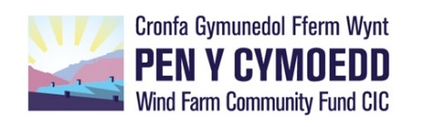 **APPLICATION TIMETABLE & KEY DATES 2023/24**

|  |  |
| --- | --- |
| **Micro Fund - up to £6,500** | |
| Round 15 Opens | 1st December 2023 |
| Application Deadline | 17.00, Monday 12th February 2024 |
| Board Meeting | w/c 18th March 2024 |
|  |  |
| Round 16 Opens | 1st June 2024 |
| Application Deadline | **17.00, Monday 12th August 2024** |
| Board Meeting | w/c 23rd September 2024 |
|  | |

|  |  |
| --- | --- |
| **Vision Fund 1: £6,501 - £26,000** | |
| **Application Deadlines** | **Board Meetings** |
| 17.00, Monday 4th December 2023 | w/c 22nd January 2024 |
| 17.00, Monday 8th April 2024 | w/c 20th May 2024 |
| 17.00, Monday 7th October 2024 | w/c 25th November 2024 |

|  |  |
| --- | --- |
| **Vision Fund 2: £26,001 - £149,999** | |
| **Application Deadlines** | **Board Meetings** |
| 17.00, Monday 12th February 2024 | w/c 18th March 2024 |
| 17.00, Monday 8th April 2024 | w/c 20th May 2024 |
| 17.00, Monday 12th August 2024 | w/c 23rd September 2024 |
| 17.00, Monday 7th October 2024 | w/c 25th November 2024 |

|  |
| --- |
| **Vision Fund 3: £150,000+** |
| Deadlines and meetings as above. Grants for over £150,000 are the exception, and assessment processes are likely to take longer. We will discuss any project time dependencies and other requirements with you at the outset. |

Feedback: usually within 5 working days of each Board meeting