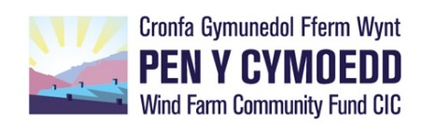
APPLICATION TIMETABLE & KEY DATES
2023
Micro Fund - up to £5,000
Round 12 Opens | 1st June 2022
Application Deadline | 17.00, Monday 15th August 2022
Board Meeting | w/c 26th September 2022
Round 13 Opens | 1st December 2022
Application Deadline | 17.00, Monday 13th February 2023
Board Meeting | w/c 27th March 2023
Round 14 Opens | 1st June 2023
Application Deadline | 17.00, Monday 14th August 2023
Board Meeting | w/c 25th September 2023

Vision Fund 1: £5,001 - £26,000
Application Deadlines | Board Meetings
17.00, Monday 10th April 2023 | w/c 22nd May 2023
17.00, Monday 16th October 2023 | w/c 20th November 2023

Vision Fund 2: £26,001 - £149,999
Application Deadlines | Board Meetings
17.00, Monday 12th December 2022 | w/c 23rd January 2023
17.00, Monday 20th February 2023 | w/c 27th March 2023
17.00, Monday 10th April 2023 | w/c 22nd May 2023
17.00, Monday 14th August 2023 | w/c 25th September 2023
17.00, Monday 16th October 2023 | w/c 20th November 2023

Vision Fund 3: £150,000+
Deadlines and meetings as above. Grants for over £150,000 are the exception, and assessment processes are likely to take longer. We will discuss any project time dependencies and other requirements with you at the outset.

Feedback: usually within 5 working days of each Board meeting

